
Catering division
Cakes
I wasn’t always a pizza guy. I’ve had a 35 year career in high and low places and a wide variety of roles. With the commercial kitchen and production facility now ready, I’m rediscovering the joy of baking and pastry work again.
Primarily intended as a B2B service for other mobile food vendors, sandwich bars, pop up vendors and cafes in the Ballarat area. It may be to compliment your existing offering or outsource to reduce staffing, inventory and equipment costs or cover a temporary staff shortage. Also available with corporate catering and for special occasions.
These are honest café style cakes made from real eggs, nuts, chocolate, fruit, butter and other whole ingredients. My skill set and interest doesn’t involve a lot of icing, decorating, artificial colours, or an endless array of novelty piping nozzles. Just good cakes,
Your cakes will be delivered within the Ballarat CBD or immediate surrounds. Cakes should generally be refrigerated although will tend to eat better at room temperature.
So, without further ado, lets introduce the new CAKE menu from the Roama Catering Division.
 Cakes
Flourless Chocolate Cake – Fudgy, moist and rich. Dressed with ganache and toasted almonds - $90

Ingredients: Dark Chocolate, Almond Meal & Flakes, Butter, Cream, Eggs, Sugar.
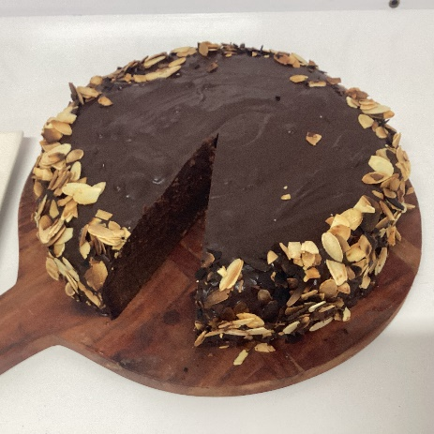

Flourless Orange Cake – Naked, dust with icing sugar - $70
Ingredients: Whole Orange, Almond Meal, Eggs, Sugar.
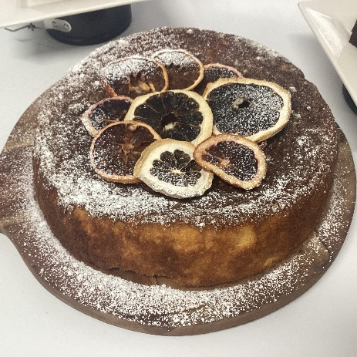

Flourless Jaffa Swirl Cake – Combo Flourless Orange and Chocolate. Naked, dust with icing sugar - $80
Ingredients: Dark Chocolate, Whole Orange, Butter, Almond Meal, Eggs, Sugar

Bread & Butter Pudding – Gentle water bath baked bread & custard cake. Glazed - $80

Ingredients: White bread, Sultanas, Butter, Jam, Cream, Eggs, Sugar (Caster and Brown)
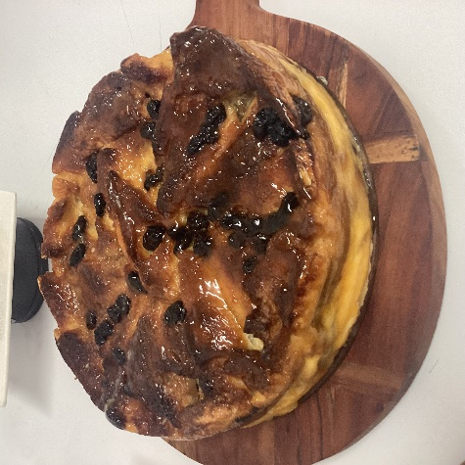

Baked Cheesecake – Biscuit base and smooth textured. Plain or easy to vary with berries or passionfruit. Glazed with optional berry garnish- $90/95

Ingredients: Neufchatel cheese, Cream, Eggs, Sugar, Marie Biscuits, Butter, optional extra Berries.
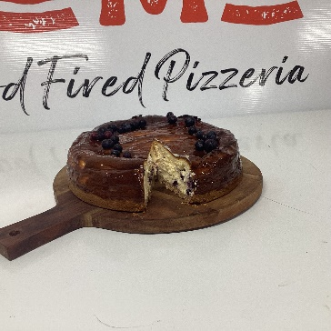

Pear & Frangipane Tart – Crisp sweet pastry base open tart filled with poached spiced pears and Frangipane (Almond butter). Easy to vary with plum or quince (POA, seasonal). Fruit is glazed, edged with Toasted almonds and icing sugar - $80
Ingredients: Flour, Butter, Almond Meal, Eggs, Sugar, Pear or other fruit
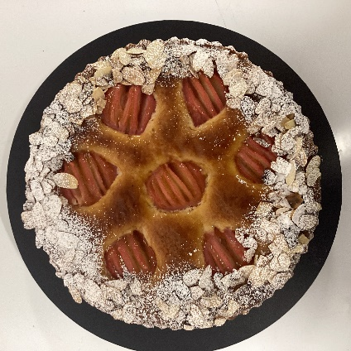

Pear & Chocolate Tart – Crisp sweet pastry base closed tart filled with poached spiced pears and ganache. Egg wash and sugar finish - $85

Ingredients: Flour, Butter, Dark Chocolate, Cream, Eggs, Sugar, Pear.
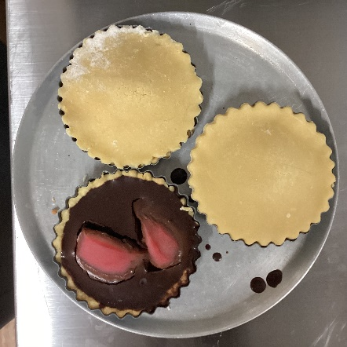

Lemon/ St. Clements Tart – Crisp sweet pastry base open tart filled with lemon/orange curd. Naked, dust with icing sugar - $80
Ingredients: Flour, Butter, Fresh squeezed Lemon/Orange juice, Eggs, Sugar, Gelatine.
Corporate catering
The flavours you know and love from Roama Mobile Wood Fired Pizzeria reimagined into a tempting selection of sandwiches, toasties, soup & salads. Please download the Corporate Catering file from www.roama.com.au/catering

And a few final important notes:
1/ Delivery available in Ballarat CBD and surrounds, typically around 11am to midday. Cakes should typically be refrigerated and served at room temperature.
2/ Ordering and negotiating any special requirements should be via email. info@roama.com.au
3/ Please allow at least one weeks’ notice to ensure stock can be ordered and processed in reasonable time. . Sunday is wholesale order night for the following week.
4/ Payment should be made via bank transfer on written agreement to supply.
5/ Allergens – we will make every effort to meet requests however it should be understood that the production facility does handle nuts, eggs, dairy, wheat flour and other typical allergens. We do not make any guarantees about the possibility of traces of these allergens in food. It is assumed that you are able to assess your own risk best.

This menu is issued January 2026, but revisions are expected in future. The latest version will be available for download for Roamas website – www.roama.com.au

Thank you for choosing Roama Catering

