
Catering division

Corporate catering
Whether you’re a regular or occasional visitor at Roama Mobile Wood Fired Pizzeria there’s bound to be some flavours that you’ve discovered and love. While onsite pizza trailer catering isn’t possible for the foreseeable future, this first version of the corporate catering menu aims to bring those flavours and more to your organisation using the same Turkish breads which are so popular as our Garlic & Cheese Breads.
The menu is intentionally simple for its first launch in October 2025. It is anticipated that future revisions may increase choices and as such, your feedback is most welcome and sought after. No automated surveys that don’t let you say what you want to. No arbitrary numerical ratings. Just jot down the thoughts of your group in an email if you have time and any improvements. That would be most appreciated to refine and improve the menu over time.
Your catering will be delivered within the Ballarat CBD or immediate surrounds. It is intended that it be consumed within a few hours of delivery.
So, without further ado, lets introduce the new corporate catering menu from the Roama Catering Division.
 Turkish Breads & Toasties
Fresh and ready to go, typically with tasty cheese or hire* a commercial toastie press and go for the hot version with gooey mozzarella. All $15 each.
HCT - Ham, Cheese, Tomato
BLT **- Eye Bacon, Fresh Tomato, Cos Lettuce and Mayo
Keyser’s Cousin – Mild Salami, Roasted Red Capsicum, Olive Tapenade, Baby Spinach & Cheese
Grilled Chicken – with Avocado, Baby Spinach, Seeded Mustard Mayo, Cheese
BBQ Chicken – with Bacon, Baby Spinach, Caramelised Onion, Cheese
Tandoori Chicken – with Red Onion, Baby Spinach, Raita. Cheese
Roast Pumpkin – with Basil Puree, Pinenut, Baby Spinach & Feta
Mediterranean Vegetable – Grilled Zucchini, Red Capsicum, Olive Tapenade, Baby Spinach & Cheese
Smoked Salmon** with Rocket, Caper Phili Cheese
**Not suited as a toastie. Recommended as fresh only
Salads
Served in a box with dressing on the side. Two sizes to serve 4 or 8, $25/$50.

Greek Salad with Tomato. Cucumber, Kalamata Olives, Feta, Cos and Lemon/Oregano Dressing (Reg/Large)

Rocket with Pear, Walnut, Parmesan and Balsamic Dressing (Reg/Large)

Panfried Haloumi & Roasted Root Vegetable Medley with Sea Salt & Fresh Herbs (Reg/Large) (Suitable for microwaving to have hot)

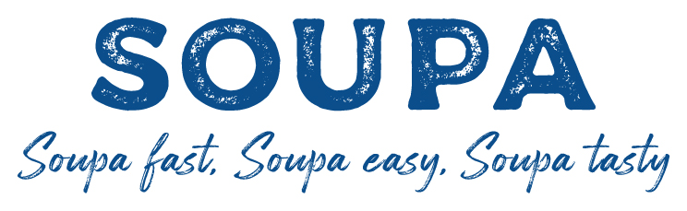
During the cooler months, hire* the soup kettle and choose your favourite soup $10/l. Allow about 250ml per person. Soup will arrive hot and should immediately be placed in the warmer on delivery. It can then hold at temperature for an extended period.
- Italian Bean with Parmesan
- Traditional Creamy Pumpkin
- Vichyssoise – Creamy Potato & Leek
- Roast Cauliflower & Blue Cheese
- Thai Style Roast Sweet Potato, Chilli & Coconut
- Winter Vegetable with Beans & Lentils
- Chicken & Sweetcorn
- Pea & Ham

Grazing boxes
Grazing box #1: Antony & Cleopatra (Designed for one or two people)
Two Meats, Cheese, Crackers, Pate, Fruit & Nuts - $29

Grazing box #2: Caesars Feast (Designed for 4-6 people)
Three Meats, Three Cheeses, Two Dips, Two Crackers, Pate, Dried and Fresh Fruit & Nuts - $79

Grazing box #3: Seasonal cut fruit assortment (Two sizes to suit 4 or 8 people)
Assortment of seasonal fruit
Regular $29
Large $59

Cakes
For a selection of cakes please download the cakes file from www.roama.com.au/catering

And a few final important notes:
1/ *Hire of the toastie press or soup kettle requires a $100 deposit, fully refundable upon return provided the units are clean, undamaged and in working order.
2/ Catering is supplied in disposable card boxes. No cutlery, crockery or utensils (soup ladle excepted) are supplied. Disposable items may be supplied at cost. Please specifically request this if required.
3/ Delivery available in Ballarat CBD and surrounds, typically around 11am to midday. It is intended that all food is consumed within a few hours of delivery to ensure all food safety standards are met. Should you wish to keep food longer, you will need to have adequate refrigeration.
4/ Ordering and negotiating any special requirements should be via email. info@roama.com.au
5/ Please allow at least one weeks’ notice to ensure stock can be ordered and processed in reasonable time. Sunday is wholesale order night for the following week.
6/ Payment should be made via bank transfer on written agreement to supply.
7/ Allergens – we will make every effort to meet requests however it should be understood that the production facility does handle nuts, eggs, dairy, wheat flour and other typical allergens. We do not make any guarantees about the possibility of traces of these allergens in food. It is assumed that you are able to assess your own risk best.

This menu is issued October 2025, but revisions are expected in future. The latest version will be available for download for Roamas website – www.roama.com.au
Thank you for choosing Roama Catering

